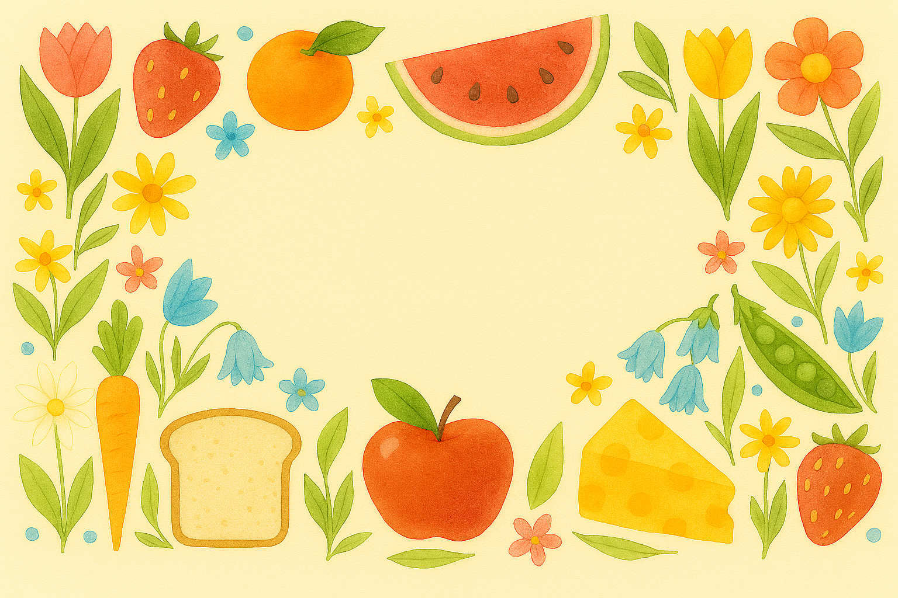
10/18/2026 - 10/24/2026
 | Sunday | Monday | Tuesday |  | Wednesday | Thursday |  | Friday | Saturday
Breakfast | Assorted Bread & Fruit  Oatmeal  Scrambled Eggs | Assorted Bread & Fruit  Oatmeal  Eggs to Order  Cream Chipped Beef | Assorted Bread & Fruit  Oatmeal  Scrambled Eggs  Strawberry Pancakes  Breakfast Sausage |  | Assorted Bread & Fruit  Blueberry Baked Oatmeal  Scrambled Eggs  Breakfast Potatoes | Assorted Bread & Fruit  Oatmeal  Scrambled Eggs  Cinnamon French Toast  Bacon |  | Assorted Bread & Fruit  Oatmeal  Eggs to Order  Sausage Patty | Assorted Bread & Fruit  Oatmeal  Scrambled Eggs  Grilled Ham
Featured Lunch | Appetizer  Cole Slaw  Entrée  Crab Cake❤  Apple Butter Pork Tenderloin  Crispy Oriental Chicken Salad  Turkey & Swiss Sandwich❤  Sides  Roasted Red Potatoes  Peas & Pearl Onions  Steamed Broccoli  Key Lime Pie | Appetizer  Cauliflower Cheese Soup  Tossed Salad  Entrée  Italian Sausage w/Peppers & Onions  Chicken Salad Sandwich❤  Turkey Chef Salad  Herb Baked Chicken❤  Sides  Macaroni Salad  Green Beans | Appetizer  Minestrone Soup  Tossed Salad  Entrée  Sloppy Joe  Italian Sub  Steak Salad❤  Herb Baked Chicken❤  Sides  Sidewinder Fries  Buttered Carrots |  | Appetizer  Loaded Potato Soup  Tossed Salad  Entrée  Ham & Pepperoni Stromboli  Seafood Salad Platter❤  Harvest Chicken Salad❤  Herb Baked Fish❤  Sides  Corn Nuggets  Green Peas | Appetizer  Beef Vegetable Soup  Tossed Salad  Entrée  Hot Turkey Sandwich w/Gravy  Chili Dog w/Cheese  Berry Almond Chicken Salad❤  Herb Baked Fish❤  Sides  Steamed Cauliflower |  | Appetizer  Maryland Crab Soup  Tossed Salad  Entrée  Mac & Cheese Entrée  Grilled Chicken Sandwich❤  BLT Salad  Sides  Stewed Tomatoes  Roasted Squash Blend | Appetizer  Split Pea Soup w/Ham  Tossed Salad  Entrée  Chili❤  Tuna Salad Sandwich❤  Shrimp Caesar Salad❤  Sides  Cornbread  Buttered Corn
Featured Dinner | Appetizer  Beef Orzo Soup  Tossed Salad  Entrée  Meatball Sub  Turkey & Swiss Sandwich❤  Crispy Oriental Chicken Salad  Herb Baked Fish❤  Sides  Onion Rings  Steamed Broccoli | Appetizer  Spinach & Egg Salad  Cauliflower Cheese Soup  Entrée  Beef Stew  Flounder Florentine❤  Herb Baked Fish❤  Turkey Chef Salad  Chicken Salad Sandwich❤  Sides  Biscuit  Roasted Parmesan Zucchini  Green Beans  Cherry Pie | Appetizer  Waldorf Salad  Minestrone Soup  Entrée  Chicken Parmesan over Pasta❤  Swedish Meatballs over Pasta  Herb Baked Fish❤  Steak Salad❤  Italian Sub  Sides  Garlic Herb Rotini  Asparagus in Brown Butter  Buttered Carrots  Lemon Blueberry Cake |  | Appetizer  Red Beet Eggs  Loaded Potato Soup  Entrée  Meatloaf w/Gravy  Honey Mustard Glazed Ham  Herb Baked Chicken❤  Harvest Chicken Salad❤  Seafood Salad Platter❤  Sides  Garlic Mashed Potatoes  Buttered Corn  Green Peas  Applesauce Pie | Appetizer  Creamy Cucumber Slaw  Beef Vegetable Soup  Entrée  BBQ Baked Pork Ribs  Honey Garlic Chicken Thigh❤  Herb Baked Chicken❤  Berry Almond Chicken Salad❤  Chili Dog w/Cheese  Sides  Twice Baked Potato Casserole  Bacon Green Beans  Steamed Cauliflower  Mini Cherry Cheesecake |  | Appetizer  Red Pepper Hummus Plate  Maryland Crab Soup  Entrée  Spaghetti w/Meat Sauce❤  Margarita Shrimp over Pasta❤  BLT Salad  Grilled Chicken Sandwich❤  Sides  Garlic Bread  Italian Vegetable Blend  Roasted Squash Blend  Banana Bread | Appetizer  Antipasto Salad  Split Pea Soup w/Ham  Entrée  French Onion Pork Chop❤  Chicken Cacciatore over Rice❤  Shrimp Caesar Salad❤  Tuna Salad Sandwich❤  Sides  Rice Pilaf  California Vegetable Blend  Buttered Corn  Peach Pie
Tossed Side Salad, Baked Potato or Baked Sweet Potato (Check Menu Jacket for Availability), Potato Chips, Pretzels, Pickles, Celery & Carrot Sticks are always available to accompany any lunch or dinner entrée. |  |  |  | Heart-healthy choices help to reduce the amount of sodium in your diet |  |  | We hope you enjoy all your meals with us. For any questions about the menu or your meals please see any member of dining services.

week one
Fall/Winter Menu

